Science Fair at River Gate Elementary School
Science and Engineering Fair
STEM WEEK Activities January 11-15, 2016

River Gate Elementary is proud to announce our Sixth Annual Science and Engineering Fair! All third grade students are expected to participate.
TASK: Students will decide on a science topic of interest and create a question they want to answer about their topic. They will design an experiment to answer the question, gather data, and write a conclusion to answer the question. They will create a tri-fold board to display their projects. The science project tri-fold board will be labeled with the following headings and include the following information:
1. Title – Your title can be the question/problem you are testing, or you may choose a clever title in non-question form.
2. “Research” – Do some research to help select your topic. Be sure to keep record of the web sites, articles, and books you read. Write a paragraph describing what you learned from your research and how that led you to your question.
4. “Question” –All good science fair projects attempt to answer a scientific question. Be sure to include your question on the board either in a headed section or as the title of the project.
5. “Hypothesis” – After reading and thinking about possible answers to the question, write an educated guess in response to the question. Support the guess by stating the reasons you believe your hypothesis is correct.
6. “Materials” – List the materials used.
7. “Procedure” – Describe the procedure used to perform the experiment. You may use photos and diagrams to clarify and explain your methods/procedures. Materials and procedures sections can be combined.
8. “Data” – Data refers to the information gathered during the experiment. Data may be quantitative (numerical) and/or qualitative (written observations and photos). The best projects include both kinds of data. Data may be displayed in tables, charts, graphs, logs, photo, etc. Encourage your child to conduct multiple trials of the same experiment and to analyze the data by finding the average of the quantitative data collected in the trials.
9. “Results/Conclusion” – Compare the question with the data and results. What is the answer to the question? Explain why you think so. Then explain ways in which the project might be improved or introduce a new question that came up as a result of the project.
Engineering/Design Projects
At River Gate, we encourage our Junior Engineers to design, create, and build. We also know that engineering projects are super fun! However, just building something for the science fair is not enough. Engineering projects must include a creative solution to a real-world problem, and the solution must be tested to see how well the design works.
To see if an engineering/design project appeals to your child, visit the following sites:
http://tinyurl.com/engineeringsfprojectsteps
http://tinyurl.com/engineeringsfprojectideas
http://tinyurl.com/sciencefairvengineeringproject

Visual Presentation
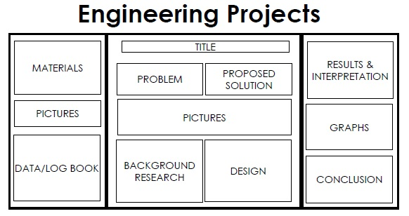
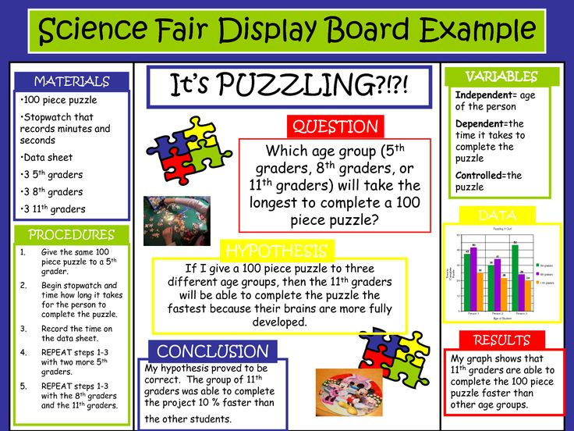
Steps 1 – 12 will be shown on standard -sized trifold boards. Headings may differ for engineering projects. See the examples, below:

Web Sites to Help With the Science Fair:

http://tinyurl.com/TopicWizard (This includes a science fair ideas wizard that allows students to complete an interest survey. The site then creates a large list of ideas tailored to the student’s interests.)
http://www.sciencebuddies.org/science-fair-projects/project_display_board.shtml
http://users.rcn.com/tedrowan/primer.html
River Gate’s Science Fair Wiki Page: http://rivergate5thgrade.cmswiki.wikispaces.net/Science+Fair
Data Collection Chart You Can Modify: http://tinyurl.com/datacharttemplate
Science Fair Presentation Outline: http://tinyurl.com/RGpresentationtemplate
For help with citing research sources: http://tinyurl.com/RGbibliographymaker

2015 Charlotte-Mecklenburg Science Fair
The top 8 projects selected by a panel of outside judges will have the opportunity to compete in the Regional Science and Engineering Fair held at UNCC in February, 2016. Parents, Science Committee members and other staff members will help students meet the requirements of participation in the regional competition.

River Gate Elementary School Science Fair
Grade 3 & 4 Contract

Work Schedule Timeline
October 22nd – Science Fair information goes home.
November 3rd – Science Fair topics due.
November 10th – Report hypothesis and materials/procedure to teacher
December 17th – Report data/results and conclusions to teacher.
Monday, January 11th – All project boards are due. Students will present their projects to their classmates.
Tuesday, January 12th – Third Grade Judging, 2:45-3:30
Tuesday, January 12th & Wednesday, January 13th – Projects judged during specials.
Thursday, January 14th – Final Judging of Grade Level Winners – A panel of outside judges from the community will select the 8 students who will compete at the UNCC Regional Science Fair. These 8 students will be selected out of the highest-scoring students on each grade level.
Friday, January 15th - A gallery crawl will be held in the morning to allow students to view each other’s projects across grade levels, and an assembly and reception will be held in the afternoon to announce and celebrate the classroom and UNCC winners.

Rules all participants must follow:
- The project must not hurt people, animals, or their possessions.
- Dangerous chemicals are not allowed.
- No projects allowed involving growing bacteria, mold or other micro-organisms.
- No type of flame is allowed at school (projects that involve use of heat or flame at home will be allowed with permission of the science committee).
- Live animals cannot come to school.
- Adult supervision is required if a task is considered unsafe, such as the use of a knife.

Name of Student: ____________________________________________________________________

Title of Project in Question Format: ______________________________________________________________________________________________________________________________________________________________________________________________________________

Brief Explanation of Project:
_____________________________________________________________________________________________________________________________________________________________________________________________________________________________________________________________________________________________________________________

I have read, understand and will adhere to the expectations, safety rules, and due dates of the science fair project.

__________________________________ _________________________________
(Student) (Parent/Guardian)
River Gate Science Fair Judging Rubric
The Judges’ Rating Scale is from 4 to 1:
4 - Above average 3 – Average 2 – Below average 1 – Not included in project
Below is a guideline to explain each judging category:

Information and Knowledge Gain: Is the information collected valid and appropriate for the grade level?
Has student acquired knowledge doing this project?
1 | 2 | 3 | 4
Does not present existing knowledge on the subject. Has learned little or no additional knowledge. | Presents some exiting knowledge on the subject and has learned some additional knowledge. | Thoroughly presents existing knowledge on the subject and has gained adequate additional knowledge. | Thoroughly presents existing knowledge, explains reason for carrying out the experiment. Has gained extensive knowledge of this subject and can accurately answer some questions that extend beyond the details of the project.  Section Total  ______

Scientific approach: Was a scientific approach used with controlled variables?
1 | 2 | 3 | 4  Section Total  ______
Explains methods and materials. | Idea is testable. Student explains methods, and materials. | Idea is testable. Student clearly explains methods, materials, and equipment used. Controlled and independent variables are loosely identified. | Idea is testable. Student used adequate sample size, and clearly and thoroughly explains methods, materials, and equipment used. Controlled and independent variables are clearly identified.

Collection of Data: Were measurements accurately taken?
1 | 2 | 3 | 4  Section Total  ______
Data is severely lacking and/or presented loosely. | Some data was collected. Student attempts to summarize data without interpreting it. | Adequate data was collected and summarized without interpretation. Figures and graphs are labeled and have titles. | Extensive data was collected and thoroughly summarized without interpretation. Evidence of data analysis is present. Data can be qualitative or quantitative. Figures, graphs, diagrams and photos are properly labeled and have specific titles.

Conclusions: Were conclusions stated and logical?
1 | 2 | 3 | 4  Section Total  ______
Results are stated with no interpretation. | Results are stated and somewhat interpreted. | Results stated and thoroughly interpreted. | Hypothesis is reintroduced, a statement of support or rejection is present.
(Over)
Oral presentation: Was well planned and interesting?
1 | 2 | 3 | 4  Section Total  ______
Project processes and conclusions are not communicated, or are confusing and unlcear. | Project processes and conclusions are somewhat communicated. | Project processes and conclusions are adequately communicated. | Project processes and conclusions are adequately and clearly communicated in an interesting way.

Exhibit: Is it visually appealing, neat and attractive?
1 | 2 | 3 | 4  Section Total  ______
Information is unorganized and inadequate. | Information is either unorganized or inadequate. | Basic information is organized on the display. | Extensive information is neatly organized and visually appealing.

Creativity and Originality: Does the project show a creative approach in thought design or presentation?
1 | 2 | 3 | 4  Section Total  ______
No creativity or originality is demonstrated. | Some creativity and/or originality are demonstrated. | Adequate creativity and originality are demonstrated. | High levels of creativity and originality are demonstrated.  Audience is unlikely to have seen a similar project in the past.

Total Score ____________/28

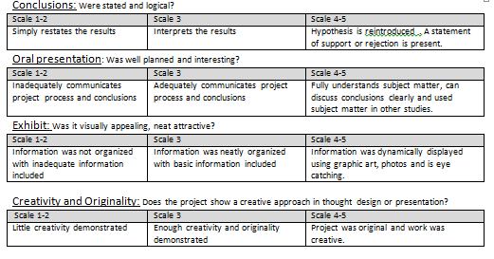
Judging Criteria
Students’ projects will be graded based on this criteria.

